Maths in Year 6
Calculation methods
In Year 6, we look at building on prior knowledge from year 4 and 5 and continue building conceptual number sense up to ten million. Here is an overview of the key arithmetic skills taught in year 4 and how the knowledge is acquired.

Addition:
• To use the formal column addition method to add numbers using the thousand column with regrouping.
• To use the formal addition method to add decimals.
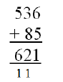Once children have mastered partitioning (in previous years), they will move onto the formal written method. This will then include decimal numbers.
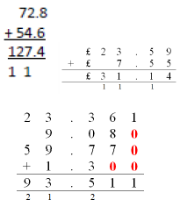

Subtraction
Children will use the formal written method for subtraction.
- To use the formal column subtraction method to subtract numbers using the millions column with regrouping.
• To use the formal subtraction method to subtract decimals
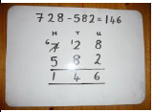
Once they have mastered this, this will include decimal numbers too.
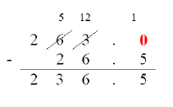
Multiplication
In year 6 we will be using the formal written method to complete short multiplications and long multiplications.
- To multiply a four digit and one digit number together using the short multiplication method.
• To multiply a four digit and two digit number together using the long multiplication method
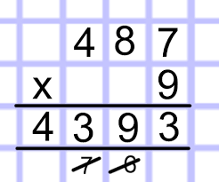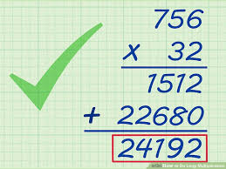

Division
In year 6, we use short division and long division methods to solve calculations.
• To divide a four digit number by a one digit number using short division.
• To divide a four digit number by a two digit number using short or long divsion.
• To divide numbers and interpret the remainders depending on the context (converting to decimals or fractions)
